MODERN HEATLCARE

OPERATIONS
April 06, 2019 01:00 AM

Police collaboration, machine-learning algorithms expedite care for gunshot victims
JESSICA KIM COHEN
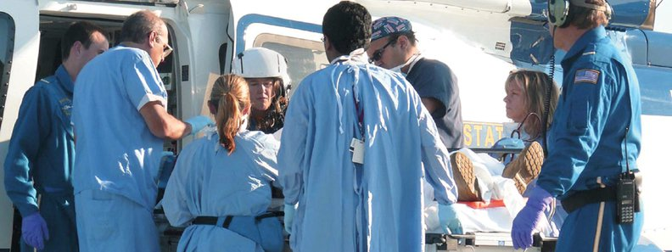
Time is precious as a patient arrives at Cooper University Health Care’s trauma center.
Gunshot-wound patients are more likely to die in the hospital than victims of other violent injuries—including those from car accidents, stab wounds and blunt trauma. One reason: Gunshot-wound patients tend to lose more blood from their injuries.
These patients are five times more likely to need blood transfusions and, on average, require 10 times more blood units than other trauma patients, according to a 2018 study published in the journal Transfusion.
“People can bleed to death in minutes,” said Dr. John Porter, director of the center for trauma services at Cooper University Health Care. “The faster we get the person to the hospital, the better.”

Cooper, a health system based in Camden, N.J., has tackled this problem head-on by collaborating with local police and a technology company called ShotSpotter.
“People can bleed to death in minutes. The faster we get the person to the hospital, the better.”
Dr. John Porter
Director
Center for trauma services
Cooper University Health CareCooper operates the only Level 1 trauma center in southern New Jersey. That’s a huge responsibility, given that Camden alone has a population of 75,000 and consistently ranks as one of the most dangerous cities in the U.S., according to real-estate database NeighborhoodScout. In 2018, Cooper treated 115 gunshot-wound patients.

“Basically, that’s one (patient) every three days,” Porter said.
Porter began meeting with the police department regularly after Cooper took over emergency medical services for Camden in 2016, including the operation of ambulance response in the city. One of Porter’s goals was to ensure victims of violent injuries were transported to the trauma center as quickly and efficiently as possible.
A feature of the collaboration between Cooper and the Camden County Police Department involves police sharing access to one of their radio channels with Cooper’s on-duty EMS team, to keep the clinicians up to date on potential gunshot-wound victims in their coverage area. The radio channel is linked with information from ShotSpotter, a tool the department uses to detect gunfire.
ShotSpotter works hand-in-hand with police departments to place acoustic sensors in select areas. These sensors pinpoint various sounds, which ShotSpotter flags as potential gunfire using machine-learning algorithms. This data is transmitted to the company’s off-site incident review center, where staff confirm the assessment and push notifications to law-enforcement agencies.
By sharing the police department’s ShotSpotter radio channel, Cooper’s EMS team now “knows that shots were fired within seconds,” Porter said.
In some cases, this means EMS can be dispatched to the crime scene almost immediately. In others, such as when there are concerns about ongoing gunfire, this notification tells clinical teams that police may soon bring a critical patient to the trauma center.
Whether the patient is transported by ambulance or squad car, the intended result is the same: The patient gets to the trauma center as quickly as possible, and trauma surgeons like Porter are ready in advance of their arrival.
“Now, when the patient shows up, my team and I are already (at the trauma bay),” Porter said.
Although police departments are ShotSpotter’s direct clients, the 23-year-old company has a newfound focus on healthcare, developed over the past year, according to Sam Klepper, senior vice president of product strategy. Some hospitals—such as Vidant Medical Center in Greenville, N.C.—have even helped fund ShotSpotter’s installation in their respective cities.
But experts caution that hospitals shouldn’t rely on the software to alert clinicians when to prep the trauma bay.
“ShotSpotter only tells you whether a gunshot was fired. It doesn’t tell you if anybody was hit,” said Dr. David Tan, president of the National Association of EMS Physicians. “I’d be afraid that hospitals could get a ‘cry wolf’ mentality if they got notified every single time ShotSpotter detected a shot.”

Tags: Operations, Innovations, Information Technology, Emergency Medicine, Public Health, Gun violence, Safety, This Week in Healthcare

